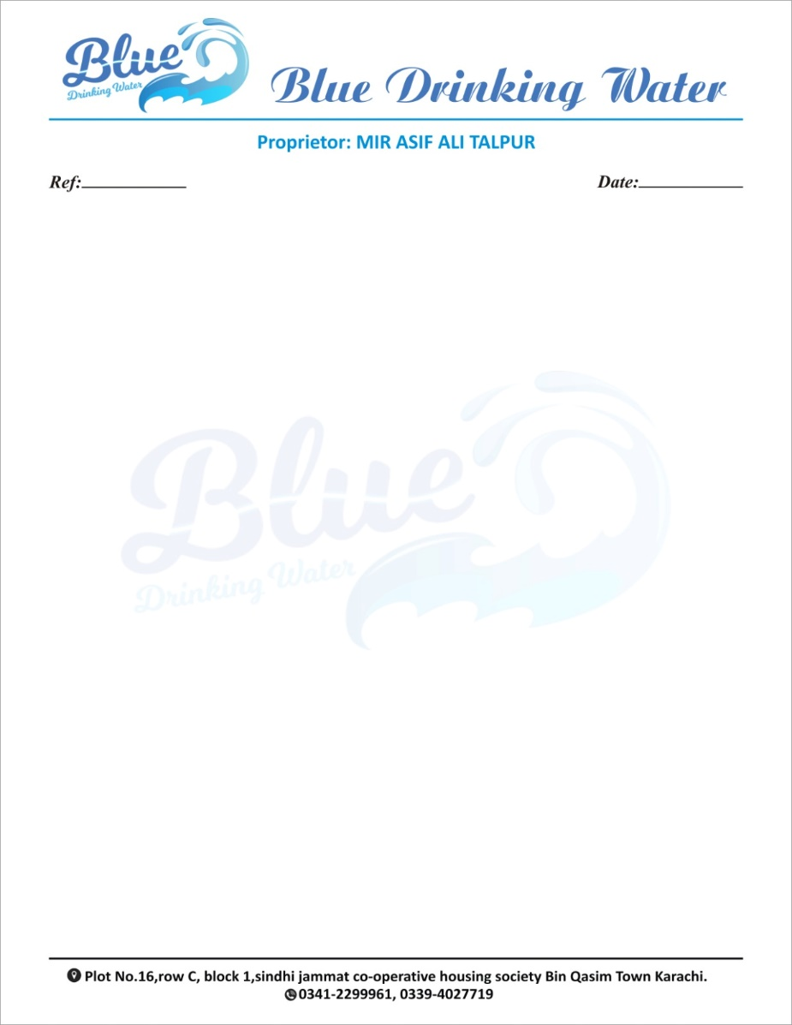
25-11-2024
SNo | Details | Rate | Qty | Total
1 | 50 ml | 50 | 50 | 2500
Total |  |  |  | 2500

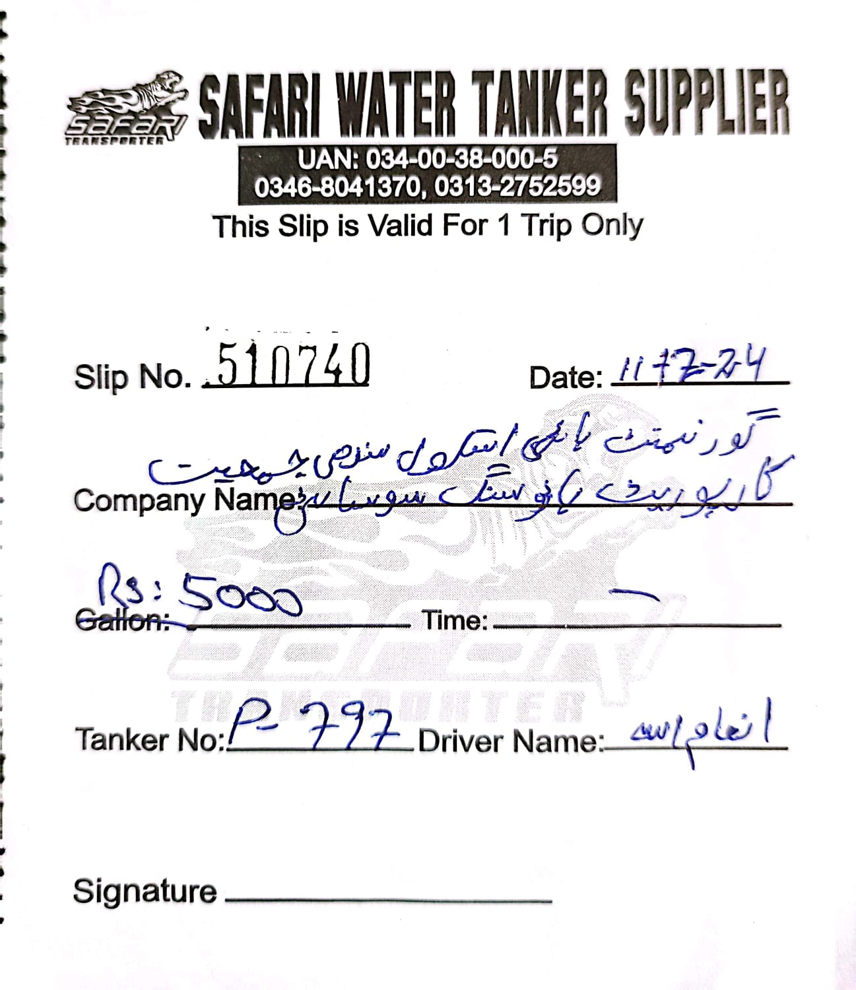

Slip No. 510740 Date: _______________

Company Name: ______________________________
Price: _______________ Time: _______________
Tanker No: ___________ Driver Name: ___________
Signature: __________________

